

Ministry of Skills Development, Employment and Labour Relations

**Name of**

**Project** Web Site for Ordering Coconut Water

|  |  |  |  |  |  |  |  |  |  |  |  |  |  |  |  |  |  |  |  |  |  |  |
| --- | --- | --- | --- | --- | --- | --- | --- | --- | --- | --- | --- | --- | --- | --- | --- | --- | --- | --- | --- | --- | --- | --- |
| M | . | K | . | P | . | P | . | G | A | M | Y | A | M | A | N | I |  |  |  |  |  |  |
|  |  |  |  |  |  |  |  |  |  |  |  |  |  |  |  |  |  |  |  |  |  |  |

**Student Name**

|  |  |  |  |  |  |  |  |  |  |  |  |  |  |  |  |  |
| --- | --- | --- | --- | --- | --- | --- | --- | --- | --- | --- | --- | --- | --- | --- | --- | --- |
| J | L | / | 2 | 2 | / | I | C | T | 5 | / | 1 | / | 0 | 0 | 0 | 7 |

**MIS**

**No**

|  |  |  |  |  |  |  |  |  |  |  |  |
| --- | --- | --- | --- | --- | --- | --- | --- | --- | --- | --- | --- |
| 2 | 0 | 0 | 1 | 8 | 2 | 6 | 0 | 2 | 4 | 6 | 6 |

**Student**

**NIC**

|  |  |  |  |  |  |  |  |  |  |
| --- | --- | --- | --- | --- | --- | --- | --- | --- | --- |
| 2 | 0 | 2 | 2 | / | 1 | 1 | / | 1 | 7 |

**Submission**

**Date**

**Center**

**Name** NVTI Baddegama

**Batch** 2022 First Batch ICT V

**Supervisor**

**Name** Mr. Nishantha Gamage

**Supervisor**

**Comments**

**Signature of**

**Supervisor**

|  |  |  |  |  |  |  |
| --- | --- | --- | --- | --- | --- | --- |
| **Official Use Only** | *Approved* |  |  | *Revised* | *Reject/Resubmit* |  |

1. **Problem Statement**

* **What is the problem?**
* There isn’t a proper online platform for our customers to seek and order the products.
* So, I’m going to build a new simple website to display our products to the customers and take orders from them.
* **Who has the problem?**
* Basically the customers.

1. **Domain/ Problem area**

* The problem area is around Sri Lanka.

1. **Proposed Solution/ Scope**

* A new website for our coconut water products ordering system. The customers can come and choose the products they want and can place the orders.

1. **Project Assumptions and Constraints**

* Project Assumptions
* All the resources are sufficient and are in a good condition.
* I might have the required skills to build the system.
* Project Constraints
* The project is an individual project.
* There are possible power cuts.
* Must complete the project within one month.
* Have to work with the available resources.

1. **Methodologies going to be used.**

* I hope to use spiral methodology.

1. **Main Interfaces in the website**

**Home page**

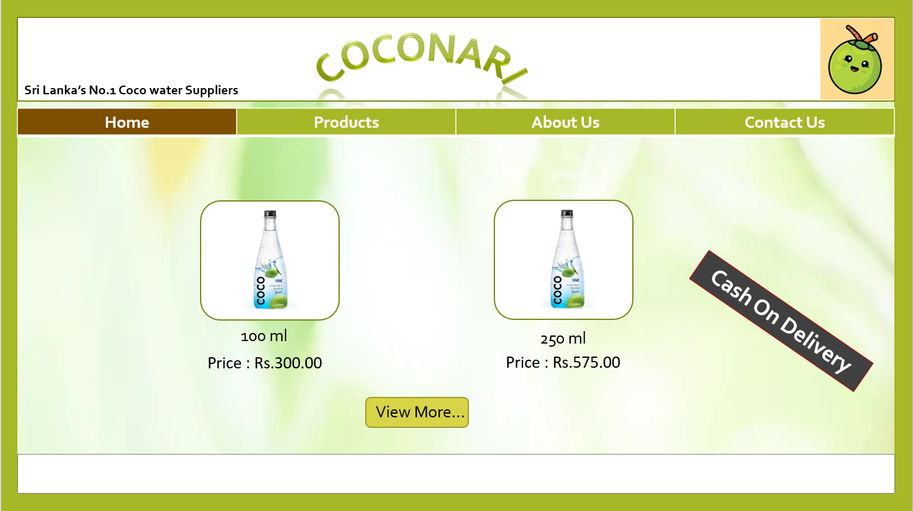

**Products page**

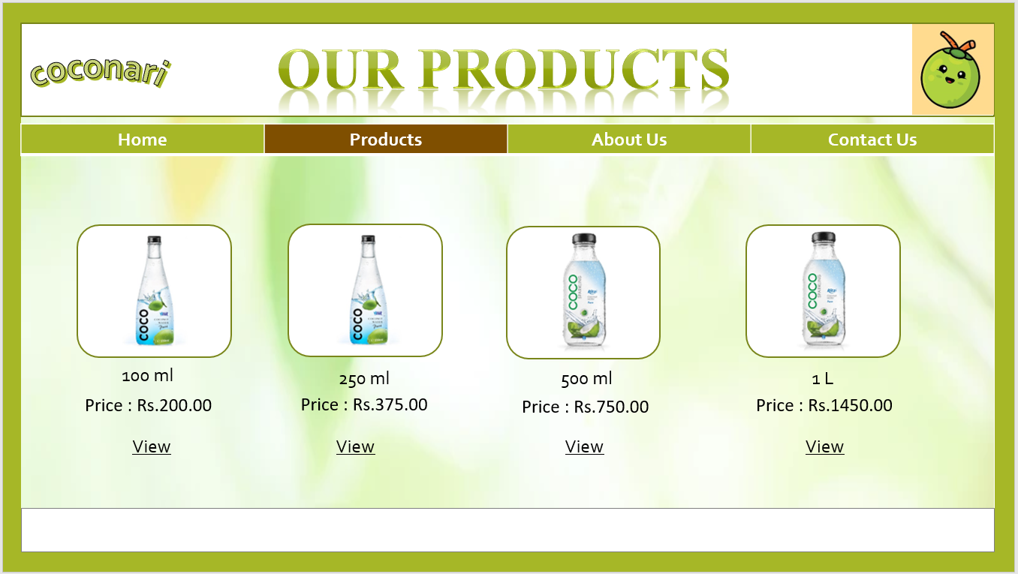

**Product review page**

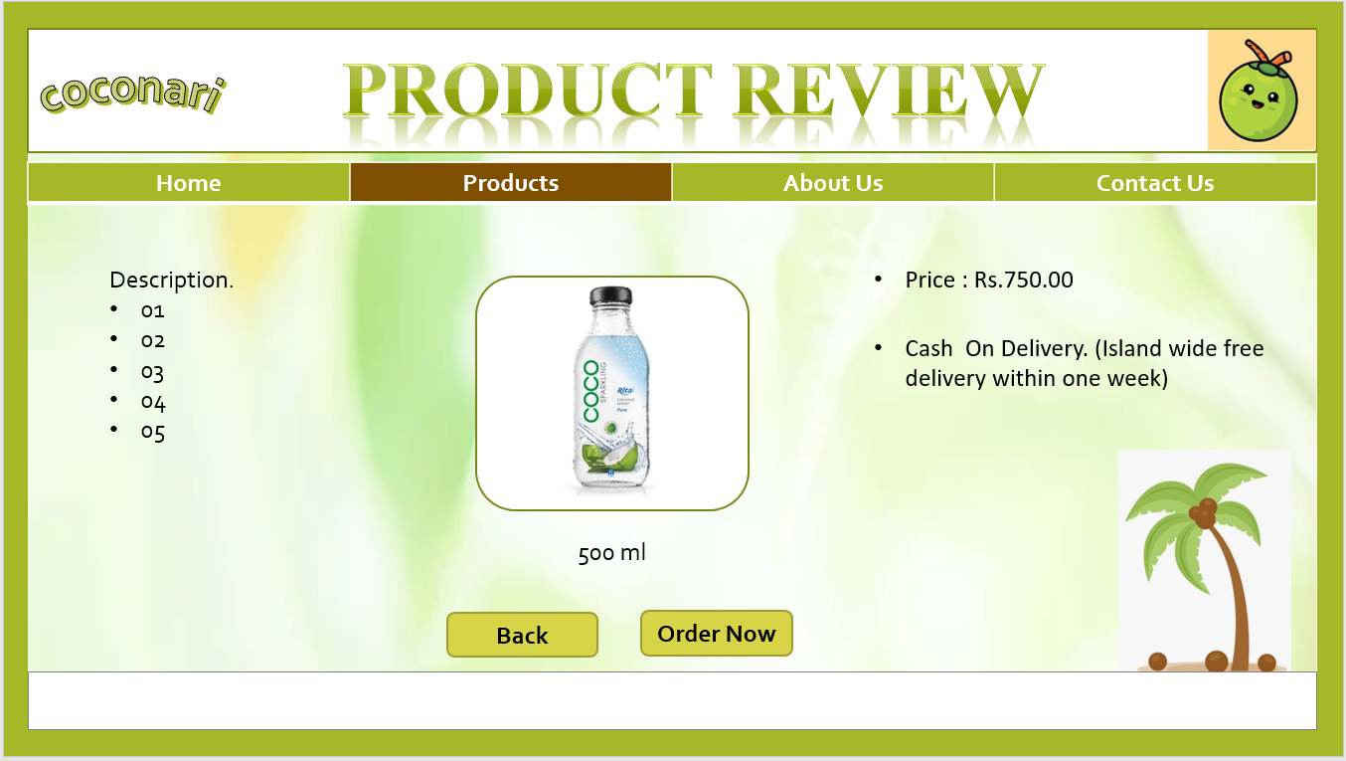

**Login page**

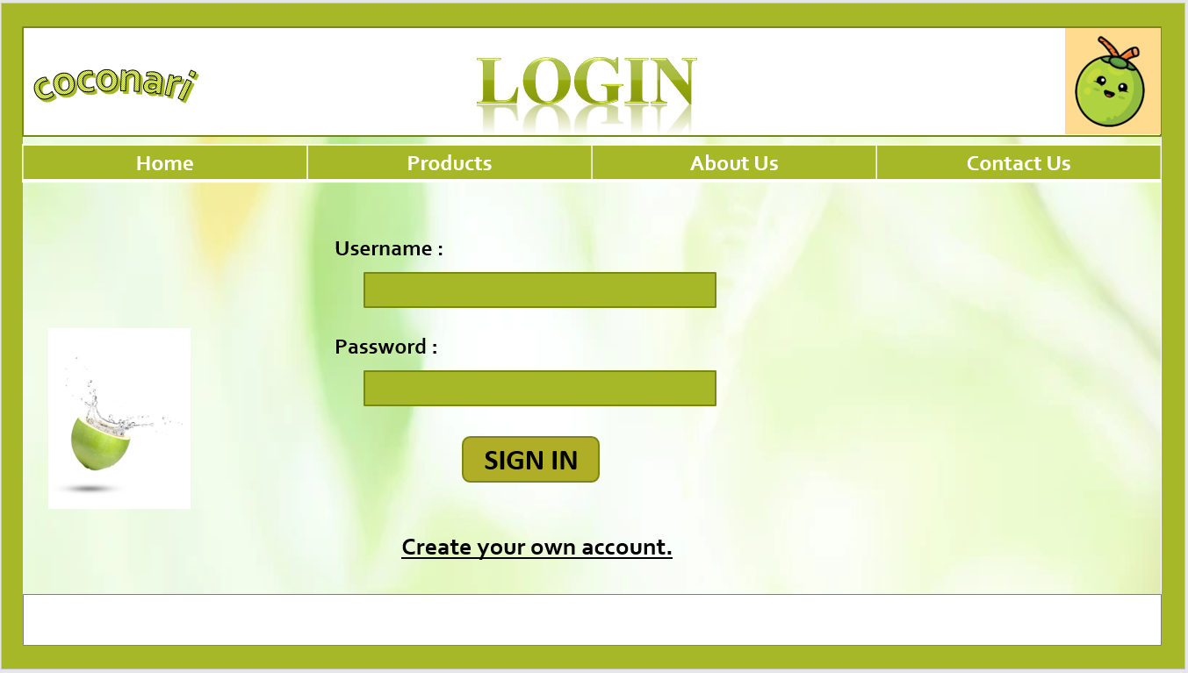

**About us page**



**Contact us page**

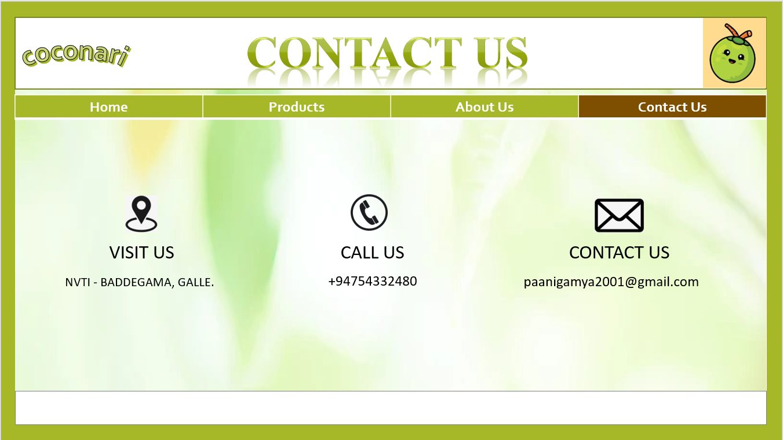

1. **Weekly Basis Project Plan**

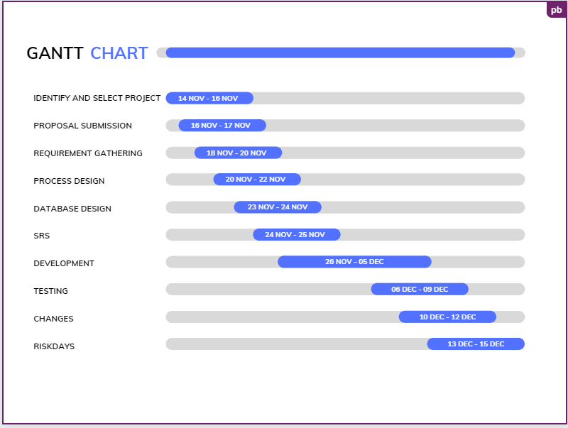

1. **Supervisor**

* Mr Nishantha Gamage

1. **Approval**